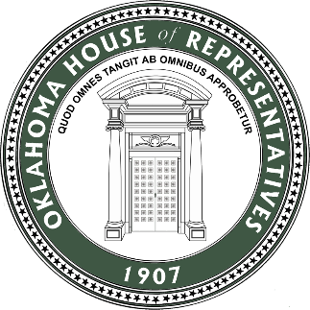
Capitol Office:
Committee Member:
Administrative Rules
Common Education
Full Appropriations and Budget
Judiciary – Civil
Government Modernization
LOFT

2300 N. Lincoln Blvd.
State Capitol Bldg. RM: 603
Oklahoma City, OK 73105-4885
(405) 557-7330
E-mail: Melissa.Provenzano@okhouse.gov

MELISSA PROVENZANO
State Representative
House District 79

Dear Neighbor,

The last half of the 59th Session of the Oklahoma House of Representatives has drawn to a close. Below are key pieces of legislation I am proud to say I authored or worked on to help become law, as well as key updates and points of information.

Supporting Working Families
HB1955 Elimination of the State Grocery Tax: Beginning in late August, Oklahomans will no longer pay the state portion (4.5%) of the tax on groceries. Estimates indicate it will save families about $400/year. I’ve been working to get this bill passed for three years, and I’m pleased to see this bipartisan effort finally cross the line!

HB3933 (Provenzano/Rader) Property Tax Exemption for fully disabled Oklahomans: For fully disabled homeowners whose income meets federal poverty guidelines, this law increases the home property value which qualifies for exemption from property taxes. Written in partnership with Tulsa County Treasurer’s office and a constituent request.

Government Transparency and Accountability
HB3937 (Provenzano/Pugh): This new law requires state agencies to post meeting notices and agendas online 24 hours prior to meeting. Up to this point, it was only required that agencies post their agendas on the front door of their building in Oklahoma City. Constituent request.

HB3053 Examining Oklahoma’s relationship with the Southwest Power Pool: After growing concerns of grid stability and rise in our monthly utility bills amid the increasing number of extreme weather events, this law requires the Corporation Commission to evaluate the relationship between the state and the Southwest Power Pool to make recommendations that will ensure price fairness, efficiency and energy availability for Oklahoma ratepayers.

Health and Mental Health
As co-chair of the Mental Health Caucus, I am proud of the progress made this year towards increasing the state’s mental health workforce. We obtained funding that will allow a 30% increase in the state’s psychiatric residencies, as well as these key laws promoted by the Mental Health caucus:

HB3190 Health Insurance - Ensuring Transparency in Prior Authorization Act: Requires prior authorizations must be handled by physicians or licensed mental health professionals who have relevant expertise This is expected to lower the number of denials and base the prior authorization process on what is medically appropriate for a patient, rather than what is least expensive for insurance companies.

HB3330 Standardized Data Collection of Oklahoma Health Care Workforce: Will streamline data collection for four boards that license behavioral health workers, painting a clearer and more complete picture of the state’s workforce over time. This will make Oklahoma one of the first states to have a comprehensive, data-driven understanding of behavioral health workforce needs.

Criminal Justice
HB3936 (Provenzano/Weaver) Combating Child Sex Abuse Material: Written in partnership with The Demand Project, this bill updates the law with clear and concise language that will help prosecute crimes related to child sex abuse material. Constituent request.

HB1835 OK Survivors Act: This law allows a judge to use discretion in sentencing when clear and convincing evidence is presented that a defendant is a victim of domestic violence.

Education
Education was again a hot topic this session. Many issues with the voucher tax credit law passed in 2023 required resolution – of note, 2 million in tax dollars meant to go to parents to pay for school tuition instead went to pay taxes owed by some who qualified for the credit. We also put a stop to Oklahoma tax dollars going to schools out of state.

Further, as a member of the watchdog committee that oversees state agency spending (LOFT), we discovered this June that close to 1.4 million dollars in federal grant money meant to be used to improve school safety and security went unspent by the State Department of Education. My caucus has renewed our call for an official audit of all State Department of Education spending, as well as efforts to secure federal grants.

SB1328 Oklahoma’s Promise: On a positive note, this law expands Oklahoma’s Promise to students seeking admission to a technology center (Career Tech) to be eligible for financial support to cover tuition for their training.

Legislative Town Halls Scheduled - Please attend in person for a post-session wrap up!

Tuesday, July 16th 6-7:30pm Thursday, July 18th 6-7:30pm
Herman and Kate Kaiser Library Hicks Park Community Center
5202 S Hudson 3433 S Mingo Road

Your Feedback Matters

What matters to you? Please call, email or scan the QR code below to respond to this brief constituent survey.
- From your perspective, has the process to obtain a driver’s license in Oklahoma improved?
- In your opinion, how can we best support our public education system here in Oklahoma?
- Do you believe it is time for an increase in the minimum wage in Oklahoma?
- What are the biggest political issues as far as you are concerned?

Thank you for the honor of serving as your Oklahoma State House Representative!

Sincerely,

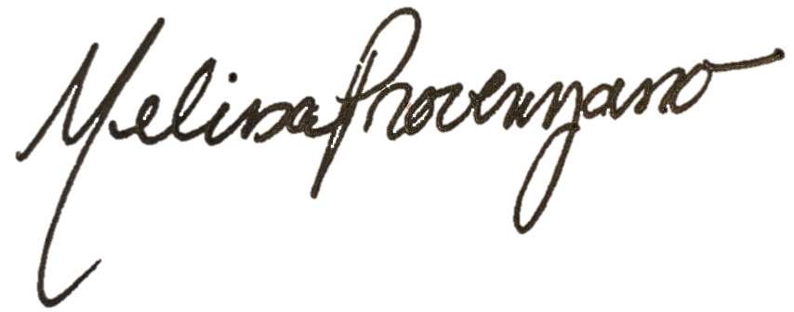

Representative Melissa Provenzano
Assistant Minority Leader
Scan for more

